Sales is Vanity, Profit is Sanity, and Cash is King: The Ultimate Guide to Financial Mastery
In the business world, a popular saying captures the essence of good financial management: “Sales is vanity, profit is sanity, but cash is king.” This phrase underscores the importance of the right financial metrics to ensure your business's long-term success and stability. Sure, high sales numbers look impressive, but it's profit—and, more importantly, cash flow—that shows how healthy and sustainable a company is. In this guide, we'll dive into what makes each component so significant, how they interrelate, and why cash flow should be your main focus. We’ll also draw insights from financial experts, include relevant case studies, and provide practical tips to help you master your business finances.
Understanding the Saying: What Do Sales, Profit, and Cash Flow Mean?
Before we get into why cash is king, let’s make sure we’re all on the same page about what each term in the saying means and how they differ from each other.
- Sales (Vanity): Sales refer to the total revenue generated from the goods or services you sell over a specific period. This figure often gets the spotlight in financial reports and marketing campaigns because it’s a straightforward measure of business activity and customer demand. But just focusing on sales can be misleading because high sales don’t necessarily mean your business is profitable or has a healthy cash flow.
- Profit (Sanity): Profit is the money you have left after deducting all expenses from your sales. It's a critical indicator of your business’s financial health and its ability to generate returns on investment. While profit gives a clearer picture of how efficiently your business is running, it doesn’t always show whether you can meet short-term financial obligations.
- Cash Flow (King): Cash flow represents the actual movement of money in and out of your business. Positive cash flow means you have more money coming in than going out, which is crucial for keeping operations running, paying bills, and investing in growth. On the flip side, negative cash flow can lead to insolvency, even if your business looks profitable on paper.
Why Sales Is Vanity: The Dangers of Chasing Revenue
The Lure of High Sales Figures
For many businesses, especially startups and those in growth phases, achieving high sales is often seen as the ultimate goal. Revenue numbers are easy to track and can be a strong selling point for investors, stakeholders, and the market at large. However, focusing too much on sales can be deceptive.
Example: Imagine a company that reports £10 million in sales for the year but spends £9.5 million on marketing, production, and overhead costs. Even though the sales figure is impressive, the profit margin is slim, leaving little room for error or unexpected expenses.
The Pitfalls of Vanity Metrics
Vanity metrics like total sales are attractive because they're easy to understand and can look good in reports and marketing materials. However, these numbers can be misleading. High sales figures might suggest success, but they don't account for underlying costs or the sustainability of those sales. For example, a business might achieve high sales through heavy discounting or aggressive marketing tactics that aren’t sustainable in the long run.
Graph: Below is a graph showing the difference between sales growth and profitability for businesses that focus solely on increasing sales without considering profit margins.

Case Study: The Rise and Fall of WeWork
WeWork, once a startup darling valued at nearly $47 billion, serves as a cautionary tale of what happens when you focus too much on sales and growth at the expense of profit and cash flow. WeWork’s rapid expansion and high revenue masked underlying financial instability. The company’s costs far outstripped its revenue, leading to massive losses and a collapse in its valuation. The focus on vanity metrics like revenue growth and market share overshadowed the more critical aspects of profitability and cash flow management.
The WeWork Debacle: Lessons in Business Strategy
Why Profit Is Sanity: The Need for Financial Health
The Role of Profit in Business Stability
Profit is a more reliable indicator of a business’s financial health than sales. It reflects your company’s ability to generate value and sustain operations over time. A business with strong profits is better positioned to weather economic downturns, invest in innovation, and provide returns to shareholders.
Table: Below is a table comparing different profitability ratios and what they mean.
Profitability Ratio | Formula | Significance
Gross Profit Margin | (Gross Profit / Sales) * 100 | Measures how efficiently a company produces goods/services
Operating Profit Margin | (Operating Profit / Sales) * 100 | Indicates profitability from core business operations
Net Profit Margin | (Net Profit / Sales) * 100 | Shows overall profitability after all expenses
Return on Investment (ROI) | (Net Profit / Total Investment) * 100 | Evaluates the efficiency of an investment
The Importance of Profit in Long-Term Planning
Profit is crucial for long-term planning. It allows businesses to invest in research and development, hire talent, expand operations, and improve their products. Unlike sales, which can be boosted by short-term tactics, profit reflects the business’s ability to generate sustainable value.
Expert Insight: According to Warren Buffett, "Profitability is the key measure of business success. Without profit, a company cannot survive in the long term, no matter how impressive its sales figures are."
Balancing Profitability with Growth
While profit is essential, it’s also important to balance profitability with growth. Businesses that focus solely on maximising profits in the short term might miss out on growth opportunities that could increase long-term value. Conversely, businesses that sacrifice profitability for rapid growth may struggle to sustain that growth without a solid financial foundation.
Why Cash Is King: The Foundation of Financial Stability
The Lifeblood of a Business: Cash Flow
Cash flow is the most critical financial metric because it shows the actual liquidity of a business. Unlike profit, which can be manipulated by accounting practices, cash flow reflects the real movement of money. Positive cash flow ensures that a business can meet its obligations, invest in growth, and survive downturns.
Why Cash Flow Matters More Than Profit
A company can look profitable on paper but still fail due to poor cash flow management. For example, if a business has high profits but its cash is tied up in accounts receivable or inventory, it may struggle to pay its bills. Cash flow problems are one of the leading causes of business failure, especially for small and medium-sized enterprises (SMEs).
Case Study: The Collapse of Blockbuster
Blockbuster, once a giant in the video rental industry, is an example of a company that failed to manage its cash flow effectively. Despite generating significant revenue and profits, Blockbuster struggled with high operating costs and declining cash flow. The company was unable to adapt to the digital shift in the market, leading to its eventual bankruptcy.
The Fall of Blockbuster: Lessons in Business Strategy
How to Improve Cash Flow Management
Managing cash flow effectively is crucial for business success. Here are some strategies to improve cash flow management:
- Improve Receivables Management: Implement stricter credit terms and follow up on overdue invoices to ensure timely payments.
- Control Expenses: Regularly review expenses and cut unnecessary costs to improve liquidity.
- Optimise Inventory Management: Reduce excess inventory to free up cash tied up in stock.
- Secure Financing: Establish lines of credit or short-term loans to cover cash flow gaps during slow periods.
Expert Insight: "Cash flow is the lifeblood of a business. Without sufficient cash, a company cannot pay its employees, invest in new products, or even keep the lights on. Managing cash flow should be a top priority for every business owner," says Robert Kiyosaki, author of Rich Dad Poor Dad.
The Interrelationship Between Sales, Profit, and Cash Flow
While sales, profit, and cash flow are distinct metrics, they are deeply interconnected. Understanding their relationship is key to financial mastery.
- Sales Drive Cash Flow: Higher sales generally lead to higher cash inflows, but only if the business manages its receivables effectively.
- Profit Affects Cash Flow: Profitable businesses typically generate more cash, but this depends on how the profit is managed (e.g., reinvestment, dividend payouts).
- Cash Flow Fuels Growth: Positive cash flow enables businesses to invest in growth opportunities, which in turn can drive higher sales and profits.
Example Scenario: Let's look at a practical example. Imagine it’s the end of the year, and your business reports strong sales of £5 million, a good gross margin, and controlled costs, resulting in a net profit of £1 million. Great news for growth, acquisition, and dividends, right? But remember, net profit is a snapshot at one point in time—if all your clients paid on time and you paid all your bills within the year, cash flow would be positive. But if £1 million of invoices are overdue, you'd have only your opening balance of £0k in the account, halting growth and dividend payments.
A different scenario shows what happens when the gross margin percentage drops—perhaps due to market competition or discounting. Did you notice this was happening? If this is combined with unpaid invoices, you could run out of cash, need a loan, or even face closure.
Finally, let's consider what happens when operating costs are higher than expected. This might occur if you're buying more stock because it seems like a good deal, not controlling expenses, or because your team is spending on advertising, office equipment, etc., without your knowledge—or with your approval, thinking you have enough money in the bank.
How are you managing spend in your business?
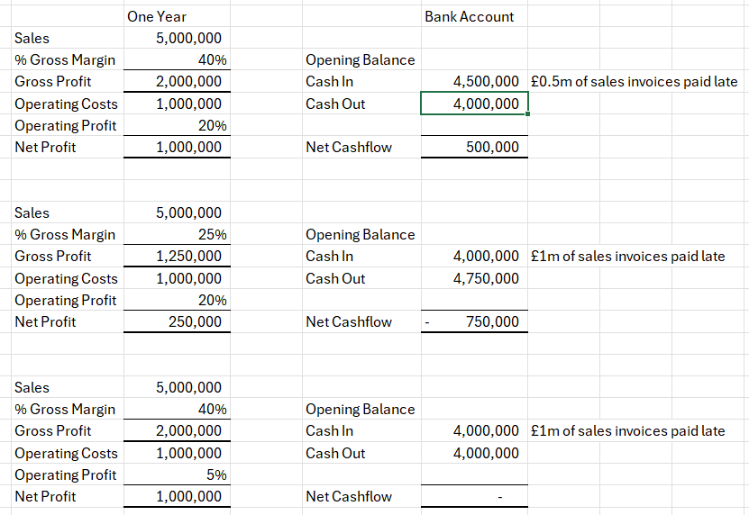

Cash flow is dynamic, whereas net profit is a static snapshot. You need a clear process for managing your cash flow to ensure you have the money to keep operating. Nothing is more stressful than constantly worrying about cash instead of focusing on sales and customer relationships.

