**Optimising Your Sales Process: A Comprehensive Guide to Boosting Efficiency and Conversions**

Sales process optimisation is crucial for businesses looking to improve efficiency, reduce costs, and ultimately increase sales. In today's competitive landscape, understanding and addressing the key pain points within your sales process can significantly enhance your results. This guide will walk you through 11 essential strategies to optimise your sales process, complete with practical application tips, real-world case studies, and actionable insights. Whether you're a solopreneur or leading a small team, these strategies will help you streamline your efforts and achieve better outcomes.

**Identifying the Bottlenecks**

One of the most common challenges in the sales process is the presence of bottlenecks that slow down progress and reduce efficiency. These bottlenecks can occur at various stages, from lead generation to closing, and can be difficult to identify without a structured approach.

**How to Apply:**

To identify bottlenecks, start by mapping out your entire sales process. This can be done using process mapping software or even a simple flowchart. Identify key stages in your sales process and look for areas where delays occur or where leads tend to drop off. Tools like sales funnel analysis can also be useful in visualising these stages and highlighting potential bottlenecks.

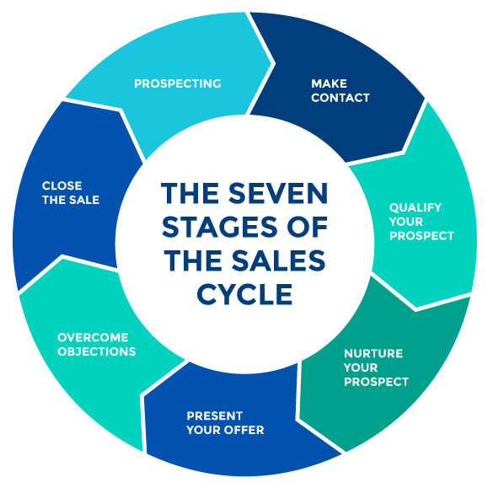

[Zen Flowchart](https://www.zenflowchart.com/guides/sales-process-flowchart-all-you-need-to-know)

**Case Study:** At a manufacturing company, Strategy121 identified a significant bottleneck during the lead qualification stage. By implementing a more rigorous lead scoring system, the company was able to reduce the time spent on unqualified leads by 30%, resulting in a 20% increase in conversions.

**Diagnosing Inefficiencies**

Once bottlenecks are identified, the next step is to diagnose inefficiencies within the sales process. Inefficiencies can manifest in various ways, such as wasted time, poor resource allocation, or ineffective communication.

**How to Apply:**

Conduct a time-motion study or review your CRM data to identify where time and resources are being wasted. Look for patterns in lost deals, such as a lack of follow-up or poor lead qualification. Pareto analysis is an effective tool for prioritising the most significant inefficiencies.

**Case Study:** A service company partnered with Strategy121 to diagnose inefficiencies in their sales process. By implementing a structured follow-up system and automating repetitive tasks, the company saw a 15% reduction in the sales cycle length and a 25% increase in overall productivity.

**Aligning Sales and Marketing**

Misalignment between sales and marketing efforts can lead to missed opportunities and decreased efficiency. Ensuring that both areas are working towards the same goals is essential for a seamless customer experience.

**How to Apply:**

Begin by setting up regular meetings between sales and marketing teams to discuss goals and strategies. Create shared content calendars to ensure that messaging is consistent and that both teams are aligned. Tools like CRM-integrated marketing platforms can help ensure that leads are nurtured consistently from first contact to close.

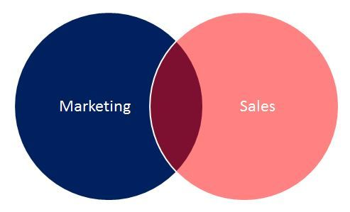

**Streamlining Lead Qualification**

Wasting time on unqualified leads can be a significant drain on resources. By refining your lead qualification process, you can focus on high-quality prospects that are more likely to convert.

**How to Apply:**

Develop a clear set of criteria for what constitutes a qualified lead, such as budget, authority, need, and timeline (BANT). Use lead scoring tools within your CRM to automatically rank prospects based on these criteria. This allows you to focus your efforts on those with the highest scores.

[A lead scoring matrix that ranks prospects based on BANT criteria.](https://blog.hubspot.com/sales/bant)

**Enhancing Sales Training**

Inconsistent sales training can lead to lost opportunities and decreased performance. Ensuring that your training programme is structured and comprehensive is key to equipping yourself or your team for success.

**How to Apply:**

Create a structured training programme that includes role-playing exercises, shadowing opportunities, and regular refreshers on product knowledge and sales techniques. Online platforms or webinars can be useful for continuous learning, and every sales interaction should be followed up with feedback for improvement.

[10 Easy steps to create as a sales training program](https://www.continu.com/blog/create-sales-training-program)

**Automating Repetitive Tasks**

Repetitive tasks can consume valuable time that could be better spent on more strategic activities. Automation can help free up this time and increase overall efficiency.

**How to Apply:**

Identify repetitive tasks in your sales process, such as follow-up emails, meeting scheduling, or data entry. Use automation tools like CRM workflows, email automation platforms, and AI-driven chatbots to handle these tasks. This will free up more time for you to focus on closing deals and building relationships.

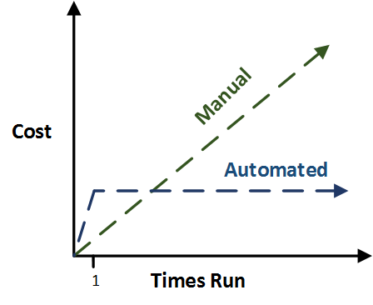

**Improving CRM Utilisation**

Your CRM is a powerful tool, but only if it's being used effectively. Improving CRM utilisation can lead to better data management, more accurate reporting, and ultimately, better sales results.

**How to Apply:**

Ensure your CRM is fully integrated with other tools, such as email marketing software and social media platforms. Customise your CRM dashboards to highlight the most critical metrics for your business. Regularly update and clean your database to avoid clutter, and use CRM analytics to gain insights into your sales performance.

[Tips for Customising Your CRM Dashboard.](https://www.findmycrm.com/blog/crm-dashboard-how-it-works-how-to-create-findmycrm#:~:text=How%20to%20design%20CRM%20dashboards%201%201.%20Select,CRM%20dashboard%20...%205%205.%20Stay%20updated%20)

**Reducing Sales Cycle Length**

Lengthy sales cycles can lead to frustration and lost opportunities. By shortening the sales cycle, you can close deals faster and increase overall sales efficiency.

**How to Apply:**

Focus on removing unnecessary steps in your sales process. Tools like e-signatures and automated proposal software can speed up the closing phase. Address objections early and effectively, and consider offering limited-time incentives to encourage quicker decisions from prospects.

*Example Graph:* A line graph comparing sales cycle length before and after implementing optimisation strategies.

**Leveraging Data for Decisions**

Data-driven decision-making is essential for optimising your sales process. By leveraging sales data, you can refine your strategies and achieve better results.

**How to Apply:**

Set up regular reporting to review key sales metrics, such as conversion rates, average deal size, and customer lifetime value. Use data visualisation tools to identify trends and patterns, and base your decisions on this data to refine your sales strategies. A/B testing can also be valuable in determining which approaches yield the best results.

[*What Is A/B Testing and How Is It Used? | HBS Online*](https://online.hbs.edu/blog/post/what-is-ab-testing)

.

**Continuous Improvement**

Optimising your sales process is not a one-time effort. Continuous improvement is necessary to ensure that the gains you achieve are maintained over time.

**How to Apply:**

Establish a routine of regularly reviewing your sales process and metrics. Stay open to new tools and techniques that could further optimise your process. Gather feedback from clients and adjust your approach as needed. Continuous learning and adaptation are key to sustaining success.

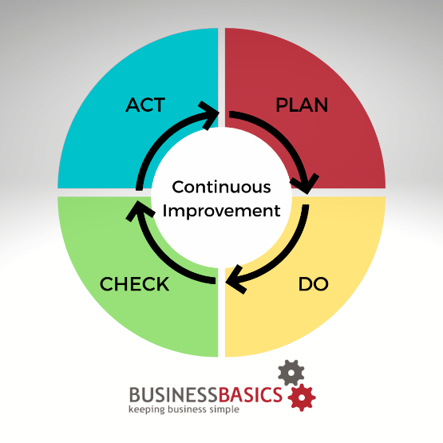

[10 benefits of creating a continuous improvement process - BusinessBasics](https://www.businessbasics.com.au/10-benefits-of-creating-a-continuous-improvement-process/#Continuous_improvement_definition)

**Defining and Tracking KPIs**

Key Performance Indicators (KPIs) are essential for tracking the success of your sales process. By defining and tracking the right KPIs, you can ensure that your efforts are aligned with your business goals.

**How to Apply:**

Begin by defining KPIs that align with your business goals, such as conversion rates, average deal size, and customer acquisition cost. Use your CRM and analytics tools to track these KPIs in real-time. Set up dashboards that allow you to monitor progress at a glance. Regularly review these metrics to assess performance, making adjustments to your strategy as needed.

Here’s a closer look at the most critical sales KPIs:

**1. Annual contract value (ACV)**

**What it measures:**The average sales amount of a customer contract over the course of a year.

**Why it’s important:** [ACV](https://www.salesforce.com/resources/articles/what-is-acv-in-sales/) helps sales reps and managers identify opportunities for upselling and [cross-selling](https://www.salesforce.com/blog/cross-selling/) that increase customer contract value and, ultimately, company revenue. If [upselling](https://www.salesforce.com/blog/what-is-upselling/) or cross-selling are not possible (due to product portfolio, pricing structures, etc.), a low ACV may indicate a need for new customers that can drive revenue growth.

**How to calculate:** (Total sales value of contracts in a year) / (number of contracts) = Average ACV

**2. Customer lifetime value (CLV)**

**What it measures:**The value of all purchases, including upsells, cross-sells, and renewals, that a customer makes over the course of their relationship with your company.

**Why it’s important:** [CLV](https://www.salesforce.com/blog/customer-lifetime-value/) is a clear indicator of how successfully your team is building the kind of trusting, value-first, and loyal customer relationships that lead to upsells, cross-sells, and renewals, and, as a result, predictable revenue. If your CLV is on the lower end, then try going over the call transcripts from your best customers. Use AI to generate call summaries that identify what moved the deal forward, then use these same tactics in future deals.

**How to calculate:**(Average purchase value per year) x (average number of purchases per year for each customer) x (average customer lifespan in years) = Customer lifetime value

**3. New leads in pipeline**

**What it measures:** The number of new leads added to each rep’s pipeline during a single quarter.

**Why it’s important:** Based on your conversion rates (four deals closed for every seven leads, for example), you will likely need a specific number of leads to hit sales targets. If reps’ lead count falls below your target KPI, it can be a sign that you need to spend more time on [prospecting](https://www.salesforce.com/blog/sales-prospecting/). A popular way to engage with more prospects is to up your presence on LinkedIn. Follow potential prospects, interact with them by liking and commenting on their posts, and then send a connection request.

**4. Average age of leads in pipeline**

**What it measures:** How long leads remain in the pipeline without becoming a closed deal. Usually calculated per rep.

**Why it’s important:**Reps know a full pipeline is a healthy one — but only if leads are actively moving toward a sale. Stalled deals are a drain on rep time that could be spent moving more viable deals down the pipeline. If you see a trend in stale leads for a particular rep, consider examining their pipeline and remove leads unlikely to close. AI insights help to quickly identify the stallers in real time so you’re not spending hours scanning through your pipeline and analyzing the data.

**How to calculate:**(Total age of all active leads per reps) / (Number of active leads) = Average age of leads in pipeline

**“Reps fall in love with deals, even if they’re stagnant. When I think about pipeline aging, if it’s stale — it’s trouble.” — Larry Long, Jr., Founder and Chief Energy Officer, LLJR Enterprises**

**5. Conversion rate**

**What it measures:** Also known as win rate, this is the percentage of each rep’s leads that are converted to closed deals. Usually tracked by quarter, per rep.

**Why it’s important:**If a single rep’s conversion rate is higher than the target conversion rate, that rep may be using sales strategies or processes that are particularly effective and can be operationalized for the entire sales team. If lower, you might need to fine-tune or streamline sales tactics to increase conversions. [Call recording and analysis](https://www.salesforce.com/sales/conversation-intelligence/) tools, alongside regular one-on-one [coaching](https://www.salesforce.com/blog/effectively-coach-sales-team-blog/), can help.

**How to calculate:**(Number of deals closed during a quarter) / (number of leads in the pipeline) x 100 = Conversion rate

**6. Rep retention**

**What it measures:**Percentage of reps who remain in your organization a set period of time after hire. Typically measured yearly.

**Why it’s important:**A low rep retention rate can disrupt carefully nurtured customer relationships, which can result in lost upsells/cross-sells — or just lost customers. It can also mean more money spent onboarding reps hired to replace those who leave. When rep retention is high, customer relationships remain intact and team stability is maintained.

**How to calculate:**(Number of total reps at the end of the year – new reps hired during the year)/(total number of reps at the start of the year) x 100 = Rep retention

**7. Average rep ramp time**

**What it measures:**The amount of time it takes a rep to get from the first day on the job to first prospect outreach.

**Why it’s important:**A quicker ramp time indicates your [sales enablement platform](https://www.salesforce.com/sales/enablement/) and training are effective, your tools and processes are intuitive, and you’re hiring qualified candidates.This results in faster sales and more engaged reps. If you find ramp time is slow, consider revisiting onboarding programs and sharing AI transcripts of winning sales calls with new reps, changing your tools, or streamlining your processes.

**How to calculate:** (Total time in days it takes all new reps to get from day one to first prospect outreach) / (total number of new reps) = Average rep ramp time

**8. Referrals**

**What it measures:** The number of referrals for new customers from existing customers secured by each rep during a given quarter.

**Why it’s important:**When your customers are over-the-moon happy with your products or services, they can serve as advocates, promoting you to prospects who otherwise may not be familiar with your brand. This makes it easier for reps to sell, leading to faster [sales cycles](https://www.salesforce.com/sales/what-is-a-sales-cycle/) and more closed deals.

**9. Customer retention**

**What it measures:**The percentage of customers who continue to buy and use your products/services. The inverse is churn rate — the percentage of customers who decide to stop buying or using your products/services.

**Why it’s important:**While new customers add to revenue, they also take [significant resources to secure](https://hbr.org/2014/10/the-value-of-keeping-the-right-customers). By watching customer retention and focusing on opportunities to upsell and cross-sell, you’re generating predictable revenue with a loyal customer base — and maximizing ROI. If you see customer retention slip, you may need to revisit rep engagement strategies to ensure your team is prioritizing existing customer relationships.

**How to calculate:** (Overall number of customers at the end of the year – net new customers acquired during the year) / (number of customers at the start of the year) x 100 = Customer retention

**Who We Are: Strategy121**

Strategy121 is a consultancy firm that specialises in helping businesses optimise their sales processes, develop effective strategies, and implement sustainable practices. Founded by Stuart Ovington, a seasoned expert in sales and strategy development, Strategy121 has a proven track record of delivering results for manufacturing and service companies. Our approach is tailored to the unique needs of each client, ensuring that our solutions are both practical and effective. Learn more about our services at [www.strategy121.com](https://www.strategy121.com).

**About Stuart Ovington**

Stuart Ovington is the founder and principal consultant at Strategy121. With over 20 years of experience in sales optimisation, financial management, and strategy development, Stuart has helped numerous businesses streamline their operations and achieve significant growth. His expertise lies in identifying inefficiencies, developing customised solutions, and guiding businesses through the implementation process. Stuart's approach is both hands-on and strategic, ensuring that clients not only see immediate improvements but also long-term success.